Six Mile Creek

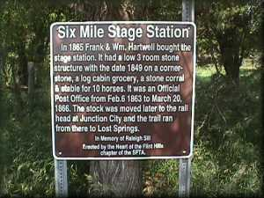s

Six Mile Creek is located in Morris County, Kansas. This location served as a vital part of the Santa Fe trail. This particular extension of the Santa Fe trail is just under 5 miles long and served as an important component to the Santa Fe trail. In these next few paragraphs I will explain why.

The information gathered thus far does not reveal an official owner just yet. What is mentioned is that the Samuel Shaft (who is presumed to be the post master) is the initial owner of this property. The Santa Fe Trail stretches 1,200 miles from Franklin Missouri to Santa Fe NM. New Mexico served as a great trading location for traders and travelers during this time. Using one of the sources I was able to find, Six Mile Creek is located East of highway 468; approximately 4 miles of a location known as Burdick.

This location is said to be a station, which opened in 1863 after the Diamond Spring station was destroyed (<http://www.forttours.com/pages/sftraileast.asp#six>). From this information I was able to glean from this website, I was able to extrapolate information that this station was used from 1867 through 1868, so only approximately a year. It is said that today only some basement walls exist and dome debris exist on this historic site. This particular site served as a vital part of the Santa Fe trail by assisting travelers on the Santa Fe

Reference links

<http://www.santafetrailresearch.com/main-route/six-mile-creek.html>

* <http://www.forttours.com/pages/sftraileast.asp>
* <https://www.nps.gov/safe/learn/historyculture/national-register-research.htm>
* <https://www.nps.gov/nr/travel/american_latino_heritage/Santa_Fe_National_Historic_Trail.html>
* <https://www.staugustine.com/news/20180829/land-trust-acquires-another-parcel-on-six-mile-creek>
* <https://www.kshs.org/natreg/natreg_thematics/view/3>
* <http://www.forttours.com/pages/sftraileast.asp#six>



